**Introduction to Python - 22AIE205**

**Name: Girish S Roll: AM.EN.U4AIE22044**

**__________________________________________________________________________________________**

1. **You are tasked with creating a program that determines whether a given year is a leap year or not. A leap year is a year that is exactly divisible by 4, except for years that are divisible by 100 but not by 400. Write a Python program that takes a year as input and prints whether it is a leap year or not.**

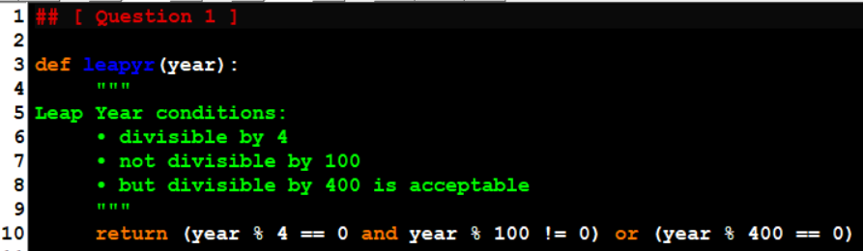

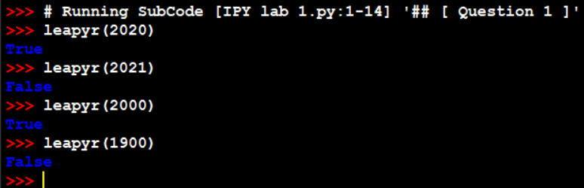

1. **You are responsible for grading the final exam of a computer science class. The grading scale is as follows:**

**A: 90-100**

**B: 80-89**

**C: 70-79**

**D: 60-69**

**F: Below 60**

**Write a Python program that takes a student's exam score as input and determines their grade using an if-else ladder. The program should display the grade earned by the student.**

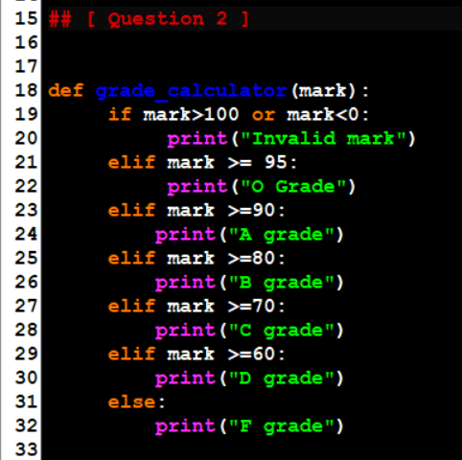

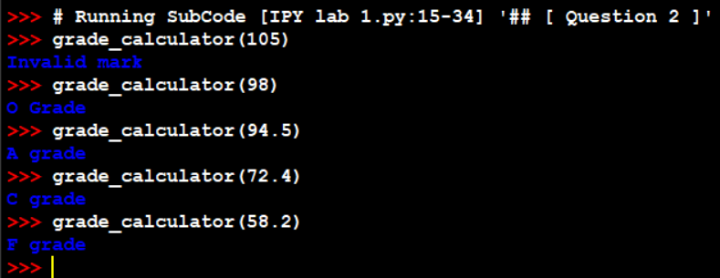

1. **You are building a program to calculate the cost of shipping a package. The cost depends on the weight of the package and the distance it needs to be shipped. Here are the rules:**

**• If the package weighs less than or equal to 2 pounds, the base cost is $5.00.**

**• If the package weighs more than 2 pounds but less than or equal to 10 pounds, the base cost is $10.00.**

**• If the package weighs more than 10 pounds, the base cost is $20.00.**

**• If the distance is less than or equal to 100 miles, there's no additional charge.**

**• If the distance is greater than 100 miles but less than or equal to 500 miles, there's a $5.00 additional charge.**

**• If the distance is greater than 500 miles, there's a $10.00 additional charge.**

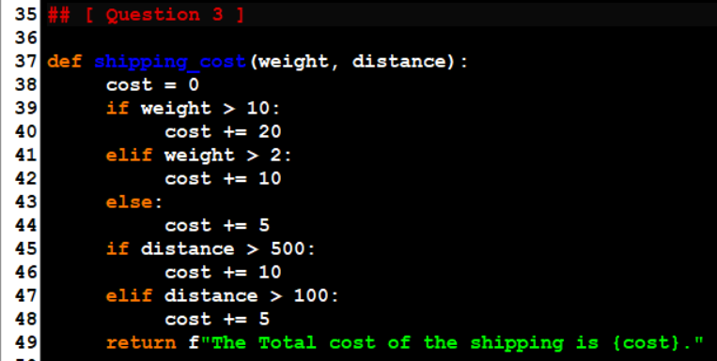 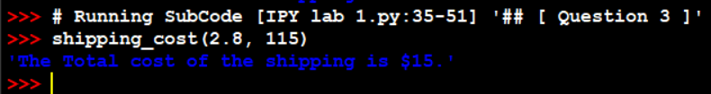

1. **Accepting user input. Write your observations of the output of (a) to (d)**

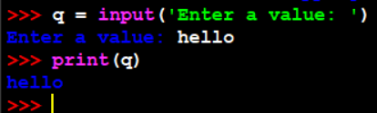

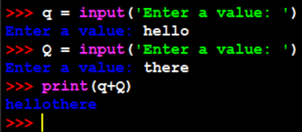

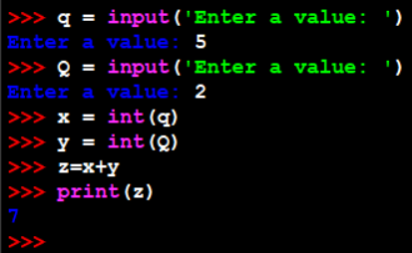

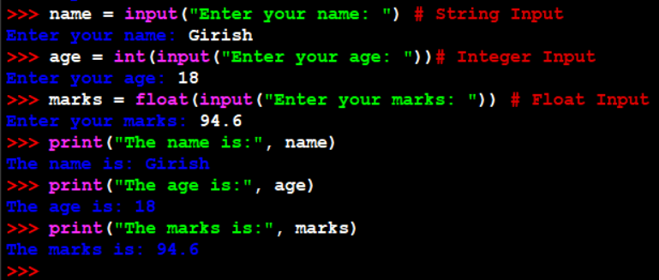

1. **Write a program to read the number of seconds and print it in the form hr:min:sec.  
     
   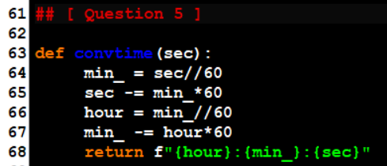 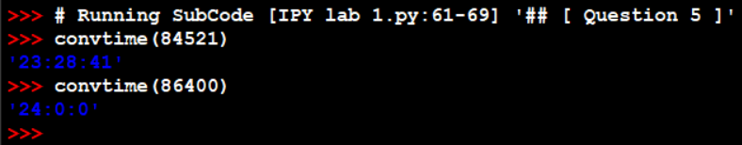**
2. **Which out of the code snippets below, print the numbers from 1 to 10. Give the reason for the error in the code snippets below which does not print from 1 to 10.**

* **All the snippets will not run due to Indentation Error.**

**[ After correcting the Indentation Error ]**

* **Snippet ‘a’ will run and print until 10 since the while condition is i<10 and not i<=10.**
* **Snippet ‘c’ will run but will print 3 5 7 9, due to the initial condition being i=3 and increment update being i+=2.**
* **Snippet ‘d’ and ‘e’ will have no output on stdout since while loop’s condition is not satisfied on the 0th iteration.**
* **Snippet ‘e’ has no increment updation resulting in a possible non terminating loop**

1. **Write a Python program that prints all the numbers from 0 to 100 except multiples of 3 or 5.  
   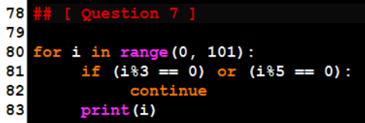 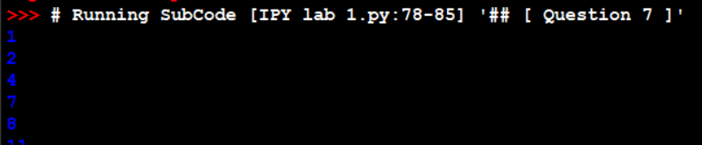**
2. **Write a Python program to take an n-digit integer and print the digits of the number from left to right and right to left.  
   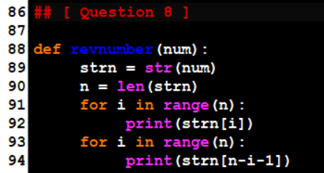   
     
   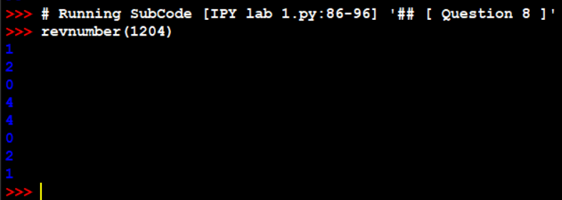**
3. **Write a python program to check if a number given by the user is a palindrome. (Hint: A number is a palindrome if the number is equal to its reverse.)  
   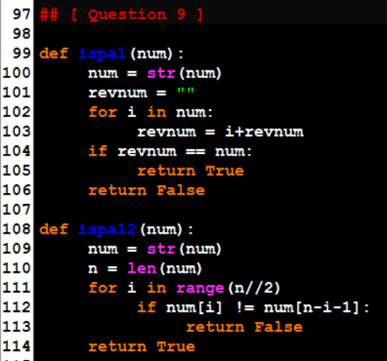 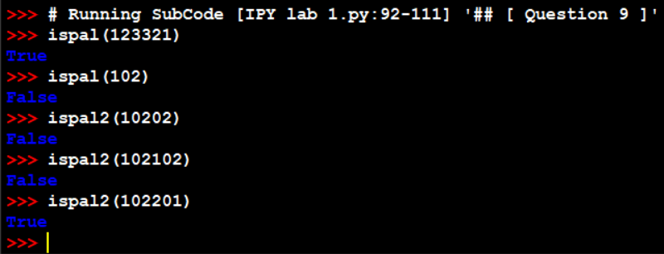**
4. **Write a Python program to find the sum of the below series provided n is a number given by the user.  
   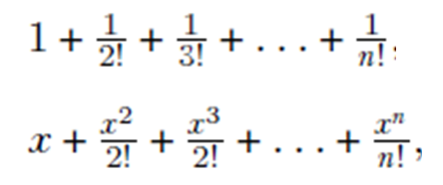 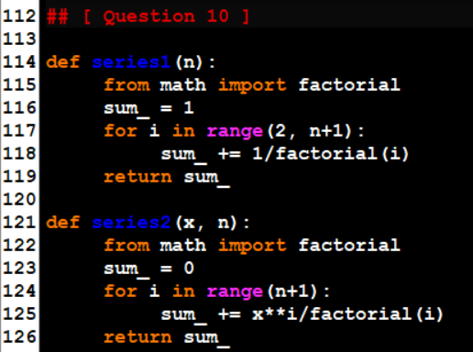 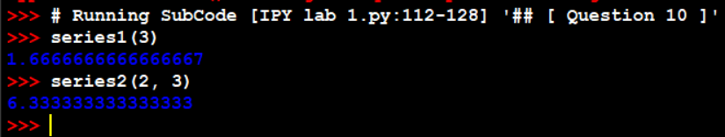**



1. **Write a program to check whether a number is strong number or not*. Strong number* is a special number whose sum of factorial of digits is equal to the original number.  
     
   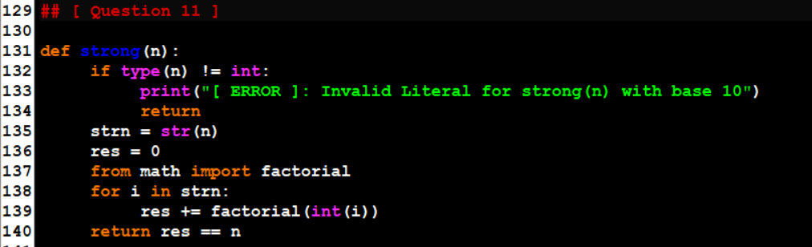 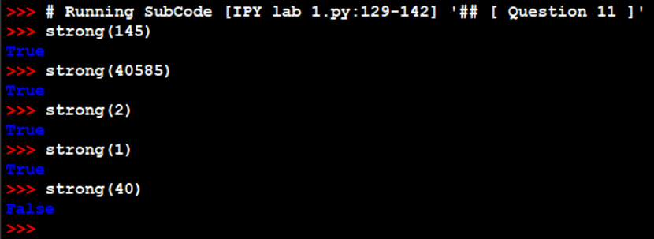**
2. **Write python program to print the below patterns. Take as input no. of rows** 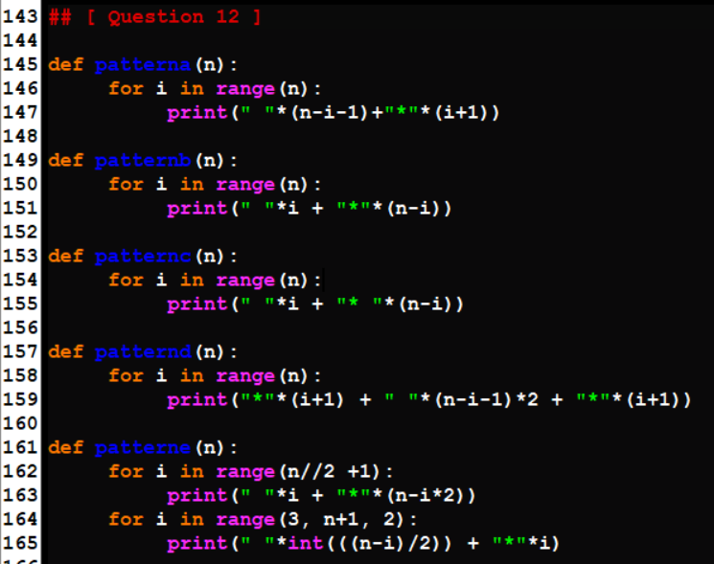

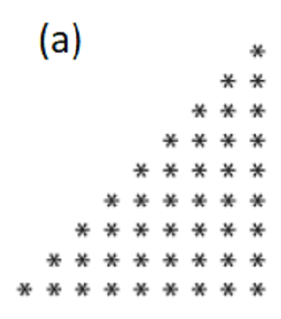 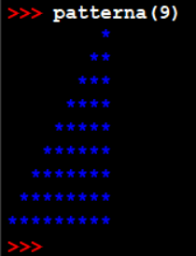  
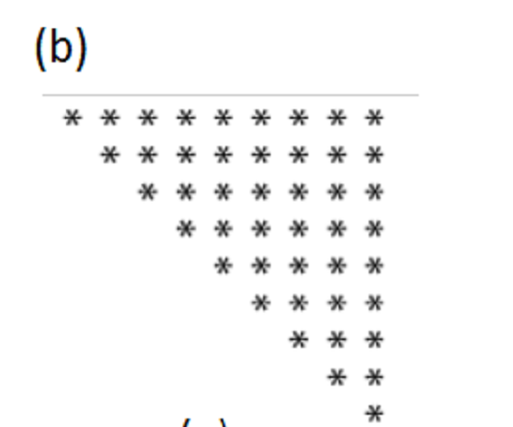 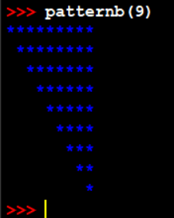  
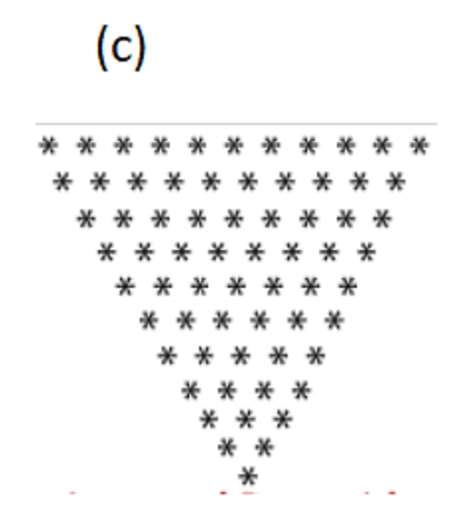 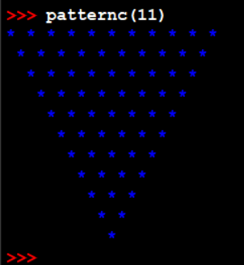  
  
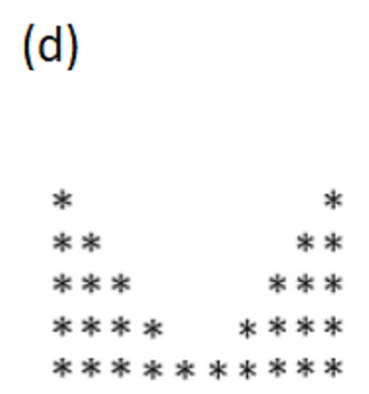 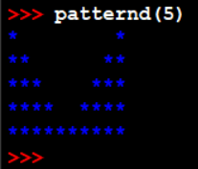  
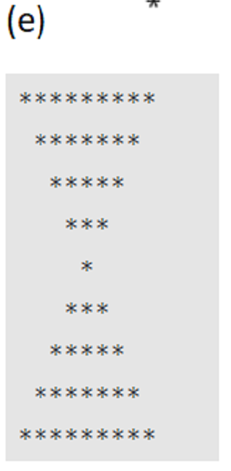 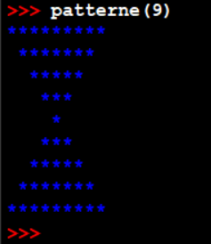

1. Write a Python program to print the below patterns.  
   